Home Theater
 | • Plasma Flat Panel TV's and LCD Projectors
 | • Pronto, TiVo Personal TV, CD Recorder, Plasma TV, HDTV, LCD Projector, DVD, and other Home Entertainment Products.
 | • Audio/Video Components, Speakers and more
 | • Plasma and SuperFlat TV's, DTV & Set-Top Boxes, and a complete line of Home Theater Products
 | • Video Displays
 | • BUILT-INvisible Systems: Audio & Home Theater Systems
 | • Audio and Video Home Theater Entertainment Products
 | • Audio and Video Components
 | • AVS/Crystalimage  Video Scaler for Projector and Plasma Displays
 | • Video Projectors
 | • Loud Speakers
 | • Whole-house Audio Systems

Home Theater Accessories
 | • Theater Touch Remote Control
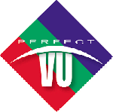 | • Projection Screens
 | • Audio and Video Mounts & Support Systems

Home Automation/Security
     | • Commercial and Residential Security Systems  • Commercial and Residential Security Systems  • Commercial and Residential Security Systems

Central Vac
  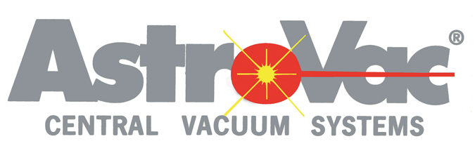  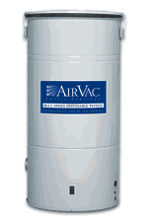 | • Dirt Devil Central Vac provided by H-P Products  • AstroVac Central Vac provided by AudioTech  • AirVac Central Vac provided by M & S Systems

Distribution Systems
 | • Modulators, Cameras, Distribution Systems, Splitters, and Combiners
 | • Satellite Multiswitches, Amplifiers, and Electronics
 | • Wireless network routing & relay

Lighting Control
 | • Decora Lighting and Fan Speed Controls Systems  • Lighting Controls Systems - Grafik Eye, RadioRA,  and Spacer

Structured Wiring
 | • Structured Wiring Systems
  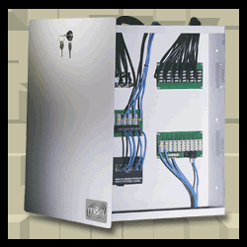   | • Structured Wiring Systems  • M & S Structured Wiring Systems  • Structured Wiring Systems

Racks & Mounts
 | • Custom home rack enclosure systems

Satellite
• Satellite Multiswitches, Amplifiers, and Electronics

Wire & Cable
 | • High Value Interconnects, Wire & Cables, and Bulk Wire Products for the Installation Specialist. Available exclusively through AVAD!
 | • HomeChoice™ - audio/video cabling products
 | • Coaxial and Cat 5 cables
 | • Coaxial Cable, RG6, Underground, and Cat5
 | • Flexible raceways for wire/cable management & protection

Power Conditioning
 | • Power surge protection

Telephony
• Residential and Business Telephone Systems, Video Teleconferencing, Door Intercoms, Voice Processing and Accessories

Wallplates & Wiring Devices
 | • Wiring Devices, Quick-Port and Wall-Mount Receptacles and Home Networking Systems
 | • LRC Series of Reference - Grade Cable F Connectors, Snap 'n Seal, and Tools

